For Immediate Release – August 30, 2024 Contact: Glenn S. Easton
(301) 428-3000 GEaston@GardenofRemembrance.org
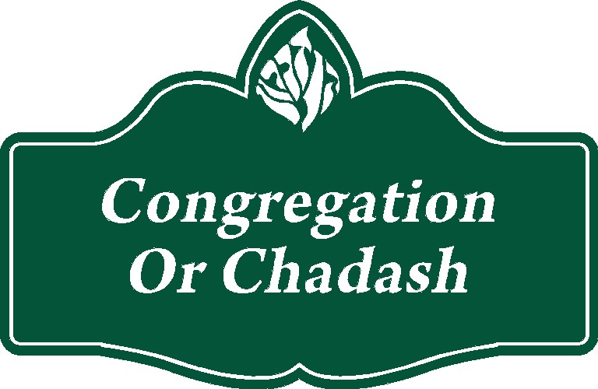
Garden of Remembrance Memorial Park
Welcomes Congregation Or Chadash as its 31st Partner Congregation

The Garden of Remembrance Gan Zikaron Memorial Park in Clarksburg, Maryland has announced that Congregation Or Chadash in Damascus, Maryland has become the 31st Partner Congregation of the Washington region’s Jewish nonprofit community cemetery.

“Geographically, Or Chadash is the closest synagogue to our Memorial Park,” notes Glenn Easton, executive director of the Garden of Remembrance. “We are pleased to welcome our neighbors and serve the families in their congregation at their greatest times of need,” he concludes.

Founded in 1984, Congregation Or Chadash is known for its excellent religious education and its open and inclusive attitude. Rabbi Alison Kobey has served as the Rabbi and Education Director of the Reform synagogue since 2009.

The Garden of Remembrance includes Partner Congregations from Orthodox, Conservative, Reform, Reconstructionist, and Renewal synagogues and serves families who are not currently affiliated a congregation. A partner agency of the Jewish Federation of Greater Washington, the 152-acre memorial park is a certified Level I Arboretum, a Hybrid Green Burial Cemetery, and a Forest Conservation Preserve.

The Garden of Remembrance Memorial Park is located near Interstate 270 (Exit 18) at 14321 Comus Road in Clarksburg, Maryland. For a complete list of the Garden of Remembrance’s thirty-one Partner Congregations and additional information about the Memorial Park, please visit www.gardenofremembrance.org or call 301-428-3000.

